**Master Functional Document**

|  |  |
| --- | --- |
| **Application** | NGERP – Centra |
| **Service Bundle** | Master Management |
| **Service Request** | Document Type |

**Description:**

Document Type in Compiere (NGERP - Centra) define the structure and processing rules for various business transactions like Sales Orders, Invoices, and Shipments. They govern document sequences, printing formats, and inter-document relationships, ensuring smooth and consistent transaction processing. These types can be customized to meet specific business requirements.

**Workflow Process:**

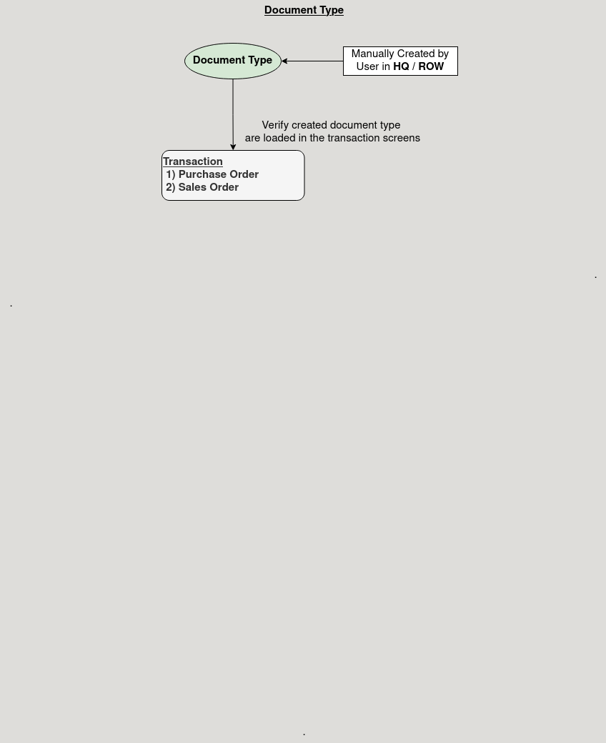

**Business Rules:**

* It is visible in both HQ and ROW.
* Creation of Document Type is possible in both HQ and ROW.
* Document types must be dsefined for each business process (e.g., Sales Orders, Invoices).
* Automatic generation of related documents like Shipments or Invoices is possible based on the document type.
* Numbering sequences are assigned to ensure each document has a unique ID.